Fractions
Equivalent Fractions
Equivalents fractions means different fractions representing the same number.
For e.g. Tipu divides the pizza into 2 equal halves and eats one half of it. Bhola divides the same pizza into 4 equal halves and eats two parts of it.
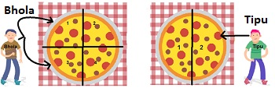
Share of Pizza eaten by Bhola = 2 parts out of 4 = 2/4.
This can be further reduced to get :
2/4 = ½ = 0.5
Share of Pizza eaten by Tipu = 1 part of out of 2 = ½.
½ = 0.5.
Thus, although the fractions are 2/4 and 1/2 but they represent the same numbers. Hence they are equivalent fractions.

